- BELLEVILLE DOWNTOWN, HISTORIC DISTRICTS & RICHLAND CREEK GREENWAY

Stamp ________________________

2. BELLEVILLE EAST YMCA

Stamp ________________________

3. BELLEVILLE SHRINE

Stamp ________________________
4. COLUMBIA

Stamp ________________________
5. A WALK TO EDWARDSVILLE PARKS

Stamp ________________________

6. FAIRVIEW HEIGHTS MALL

Stamp ________________________

7. GLEN CARBON OLD TOWN

Stamp ________________________

8. MARYVILLE CMT YMCA

Stamp ________________________

9. O’FALLON-A WALK IN THE PARKS

Stamp ________________________
WORK ONE ILLINOIS TREKKERS TRADITION EVENT

Stamp ________________________
ATTEND ONE ILLINOIS TREKKERS MEETING

Date___________________________
TRADITIONAL OR YEAR ROUND WALK EVENTS IN ILLINOIS & MISSOURI

10. Stamp _______________________

11. Stamp _______________________

12. Stamp ______________________

13. Stamp ______________________

14. Stamp _______________________

15. Stamp _______________________

16. Stamp ______________________

17. Stamp _______________________

18. Stamp _______________________

19. Stamp _______________________

Walking is a great way to exercise, relieve stress, meet new people, and see some areas in Illinois & Missouri.
The Illinois Trekkers Volkssport Club is sponsoring this 2019 incentive program.
The program is non-competitive 5k (3.1 miles) or 10k (6.2 miles) walks. Walks are by yourself, or in a group, a club, or with a family member. The Year Round walk directions are acquired at each site. A registration start card is provided in a “walk box.” The start card must be filled out prior to the walk. If it is a Traditional walk the start cards are at the registration table on that day.
For detailed information on walks:
www.ava.org
www.illinois-trekkers.org
As an incentive to explore Illinois & Missouri and be involved in the fun, fitness and fellowship of volkssporting, our goal for 2019 is to walk at least 19 events, work one Illinois Trekker traditional event & attend one Illinois Trekker meeting.
By completing this challenge, you receive “One Free Walk” coupon to celebrate your achievement. One award for each challenge completed. Coupons are only honored at Trekkers walk.
In order to receive the award you will need to walk each Trekkers event listed in this brochure & walk sanctioned Illinois & Missouri walks of your choice for a total of 19 sanctioned walks, pay the appropriate registration fee at each, and stamp the challenge book. This program ends 31 December 2019. This is not an AVA special program and there is no cost for the book.
See our Illinois Trekkers website for specific details. Approved for use of the IVV Certification Stamp by Executive Director.
Once you have completed the challenge, send the completed program book to:
Illinois Trekkers Volkssport Club
P.O. Box 603
O’Fallon, IL 62269

YOUR MAILING INFORMATION
Name _________________________
Address _______________________
______________________________
City __________________________
State _______ Zip _______________
Email _________________________

Walk 19 Events in 2019
2019 WALKING
CHALLENGE
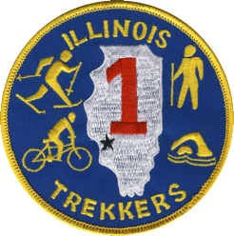
Illinois Trekkers
AVA CLUB #047
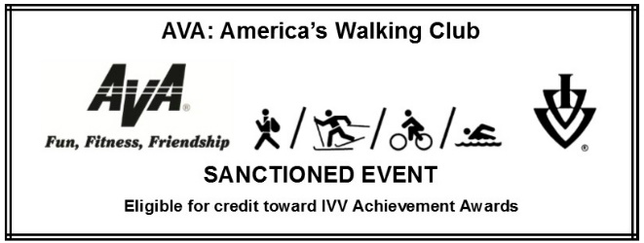

© 2019 Illinois Trekkers

