WALK WITH OUR SISTER CLUBS
YEAR AROUND
METRO STL - ILLINOIS WALKS
□ Hartford
□ Litchfield
□ Springfield - Capitol
□ Belleville-Oakland Historic District
□ Edwardsville
□ O’Fallon-Town Walk

METRO STL - MISSOURI WALKS

□ Cuba - Missouri's Mural City Walk
□ Hermann – Old Town
□ Hermann – Katy Trail Bike
□ Jefferson City - Capitol
□ Kirkwood – Historic
□ Richmond Heights 
□ Rolla - Veteran Memorial
□ St. Charles 
□ Saint Louis – Downtown
□ Saint Louis – Fabulous CWE
□ Saint Louis - Forest Park
□ Saint Louis – LeMay/JB
□ Saint Louis - Maryland Heights
□ Saint Louis - Webster Grove
□ University City - Historic University City/Delmar Loop
□ Washington

ST. LOUIS AREA AVA
WALKING Clubs ______________________________________

Illinois Trekkers
Lebanon Cedar Cruisers
Gateway Milers
Rolla Roadrunners Volkssport Club
St. Louis-Stuttgart Volksmarch Club

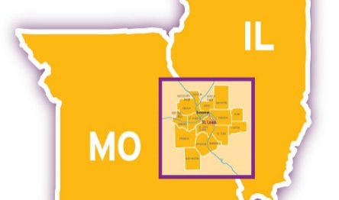
ILLINOIS TREKKERS VOLKSSPORT CLUB
YEAR ROUND (YRE)
WALK, SWIM AND BIKE EVENTS
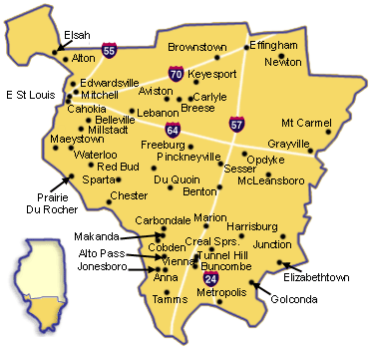
      □ Belleville, IL 3 Walks & 1 bike event       □ Columbia, IL Walk
 □ Edwardsville, IL Walk & Swim
      □ Fairview Heigts, IL Walk
      □ Glen Carbon, IL Walk
      □ Maryville, IL Walk & bike
      □ O’Fallon, IL Walk

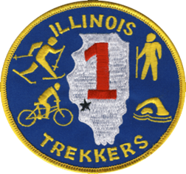
JANUARY – DECEMBER
2019
GENERAL INFORMATION
WELCOME: The Illinois Trekkers invite you to nine walking, one swimming & two biking year round events (YRE). Walk as many times as you choose – daily, weekly, monthly. We have planned them for your enjoyment as our motto states: “FUN, FITNESS, and FELLOWSHIP”.
WHAT IS A VOLKSMARCH: A leisurely walk or ride through a scenic, historic, and/or interesting area over a trail, walking path, sidewalks, and streets. These events are family oriented, noncompetitive walks done at your own pace. An international achievement program (IVV) is available to keep track of your walking or biking accomplishments.
SPONSOR: The Illinois Trekkers is a not for profit walking club located in the greater St. Louis metropolitan area. The club hosts weekly, monthly, and year around walks. Visit our Web site at www.illinois-trekkers.org Address: Illinois Trekkers, PO Box 603, O’Fallon, IL 62269

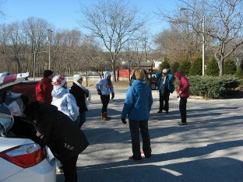
REGISTRATION LOCATION/TIMES: Each Illinois Trekkers YRE walk, swim or bike ride has its own self-registration/start point. Locate the “Walk Box” at each YRE location. A specific Walk Box location (where you self-register) is provided in each event listing. Follow the registrations directions found in the Walk Box. Each walk, swim or bike event has a time for use of the trail, such as “dawn to dusk.”
DATES: All YREs are hosted from January to December 2019. Not all “walk box” registration sites are open on holidays. Refer to the specific site information.
TRAILS: Trails vary. The trail rating guide helps you to determine your use of a specific trail. Ratings include:

AVA TRAIL/ROUTE RATING SYSTEM
 | Part 1 – INCLINE/  ELEVATION |  | Part 2 - TERRAIN
1 | Very small hills or very little stair climbing. | A | Almost entirely on pavement.
2 | Some moderate hills or stair climbing. | B | A significant part of the route is on well-groomed trails with very few obstacles.
3 | Some significant hill or stair climbing. | C | A significant part of the route is on somewhat difficult terrain (rocky/rooted paths or soft sand.)
4 | Lots of significant hills or stair climbing. | D | A significant part of the route is on very difficult terrain.
5 | Many steep hills. | E | The majority of the route is on very difficult terrain.

DISTANCE: Generally the walk distances are 5K (3.1 miles) and 10K walk (6.2 miles). Biking events are longer. Refer to the individual events for exact distances.
FEES AND PROCEDURE: $3.00 per participant. At the time of self-registration each participant must fill out and sign a start card before beginning the event. A START CARD MUST BE FILLED OUT. Carry this card with you to the finish point. All start cards remain the property of Illinois Trekkers and must be turned in when the event is completed. Please complete your registration according to the directions indicated in the Walk Box. Your start card is mailed along with your payment to the Point of Contact (POC).
INFORMATION CONTACT:
Every event has a POC who has the most current information about a specific event. They also receive your payment and start cards. They complete all incident and accident reports for a specific trail. Contact the POC for additional information about the event.

SAFETY: Your safety is a primary concern. You should remain vigilant along the routes for route deficiencies, traffic, weather related conditions, construction, and unexpected events. Report all incidents and/or accidents to the POC.
STIPULATIONS: All events are open to everyone. No refunds are given for any monies paid. The events are offered regardless of weather conditions.
DISCLAIMER: The Illinois Trekkers Volkssport Club, AVA, or IVV cannot be held liable for accidents, theft, material damage, and/or injury. Every reasonable effort will be made by the sponsors to make this a safe, enjoyable, and memorable event. Children age 12 and under must be accompanied by an adult. By self-registering for these events, the participant agrees to these conditions.
MISCELLANEOUS: Be sure to bring your camera and dress according to weather conditions. Parking is available at the Start Points. It is noted for each walk whether pets are welcome and in all cases they must be leashed at all times and the owner is responsible for cleanup. Water should be carried on all events. Suitability of the trail for strollers, wheelchairs, and wagons is indicated for each walk. Restrooms are not guaranteed at all start points and indicated on the listing for each event.
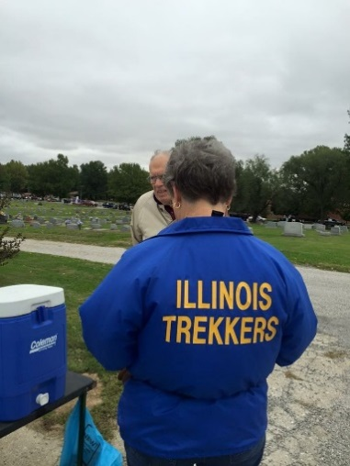
SANCTION: All walk and bike events are sanctioned by AVA. Please refer to the specific event for the sanctioning number.

GENERAL INFORMATION:
Illinois Trekkers Web Site: www.illinois-trekkers.org
ADDRESS
Illinois Trekkers
PO Box 603
O’Fallon, IL. 62269

American Volkssport Association Web Site: www.ava.org

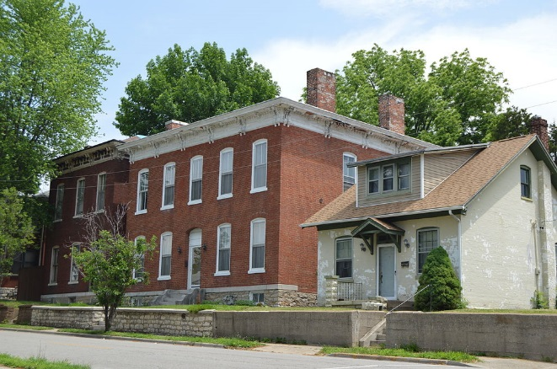

Dates: 1/1/2019 - 12/31/2019
City / State: Belleville, IL
Event Name: Downtown, Historic Districts & Richland Creek Greenway
Event Type: Year Round Walk
Event ID: 111578 2019/Y0904
Distance - Trail Ratings: 5/10km - 1A

Description: Daily, dawn to dusk. Check payment preferred. Restrooms and water are available at the start/finish and at several locations along the trail. The Richland Creek Greenway connects six city parks. After leaving the greenway you will traverse through two historic districts and a beautifully renovated downtown streetscape. The Fountain square is host to many events throughout the year. Saturdays, May-October, you can catch the Farmer's Market. The third weekend in May is "Art on the Square," voted #1 in the country in 2011 and 2013. The last weekend in June is the "Jazz and Wine Festival." September brings the Oktoberfest and the first weekend in October is the Chili Cook-Off. Info www.belleville.net.
Amenities: Strollers: Medium
Wheelchairs: Medium Pets: Yes Restrooms: Yes
Special Programs: Bridges - Spanning the USA, Make a Wish at a Water Fountain, Take a Walk In a City Park, & Walking the USA A - Z
Start Times: Daily, dawn to dusk
Location: Balance Coffee and Tea, 732 S. Illinois Street (Highway 159), Belleville, Illinois. Driving Directions: I-64, Exit 12 (IL-159) S. Continue through Swansea to downtown Belleville, around the Fountain, staying on Illinois Street (IL-159) to Balance Coffee and Tea (Train Depot) on your left at 732 S. Illinois. Free parking is available. Balance Coffee and Tea is open seven days a week. Walk binder is available on the shelf to the left of the cashier. More information on hours and holiday closings at balancecoffeeandtea.com or (618) 641-9900. Awards & Fees: IVV Credit Only
Comments:
Host Club: Illinois Trekkers Volkssport Club
Contact: Susan Hodgson (618) 334-6304 Website: www.illinois-trekkers.org
E-Mail Contact: lkcs246@gmail.com

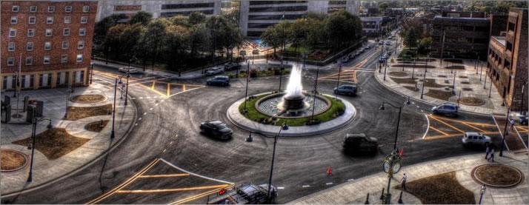

Dates: 1/1/2019- 12/31/2019
City / State: Belleville, IL
Event Name: Shrine
Event Type: Year Round Walk
Event ID: 111751 2019/Y0226
Distance - Trail Ratings: 5/10km - 2B

Description: Daily, dawn to dusk. Please pay by check only. Many beautiful sites on location as well as The Shrine Restaurant and The Shrine Gift Shop and Book Store. Walk is on paved streets with some gradual hills. They are tree lined with beautiful landscaping, inspirational sculptures, and religious buildings. Water and restrooms are available at the start/finish as well as certain locations along the walk.
Amenities: Strollers: Hard Wheelchairs: Hard Pets: Yes Restrooms: Yes
Special Programs: Amphitheatres
Start Times: Hotel Desk is open 24/7
Location: Shrine Hotel of Our Lady of the Snows
Start Point / Driving Directions: Toll Free 1-800-682-2879 or local 618-397-1162. 451 S De Mazenod. I-64, I-55 or I-70 take I-255 S to exit 17 to Illinois Hwy 15. Follow Hwy 15 E to entrance of Shrine on right. Belleville, take Hwy 15 W to entrance of Shrine on left. On grounds, follow signs to Shrine Hotel. Walk Binder located at hotel check-in desk. The hotel desk is open 24/7.
Awards & Fees: IVV Credit Only
Comments:
Host Club: Illinois Trekkers Volkssport Club
Contact: Jackie McKay (618) 616-1330
Website: www.illinois-trekkers.org
E-Mail Contact: jjmck1985@gmail.com
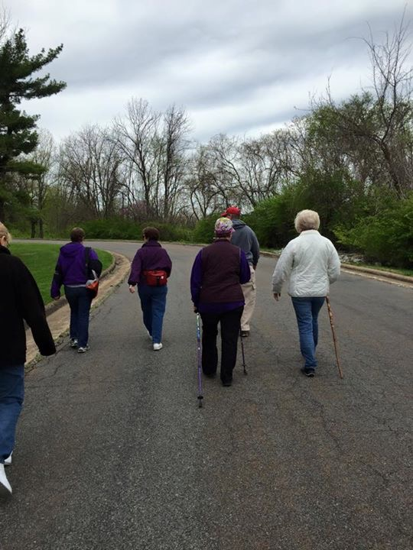

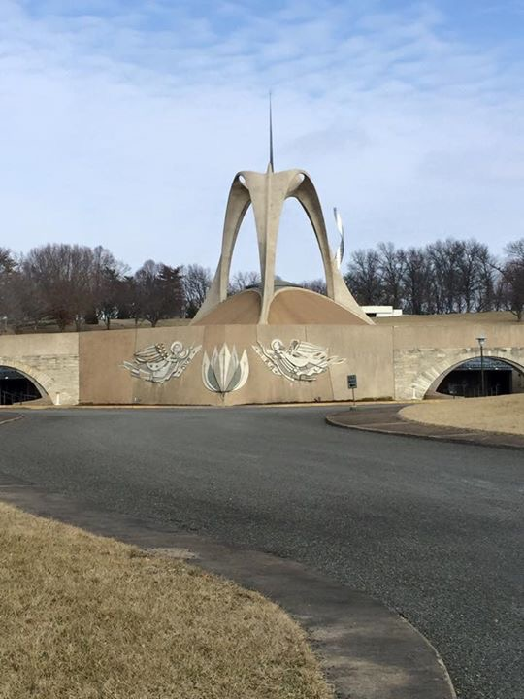

Dates: 1/2/2019 - 12/31/2019
City / State: Belleville, IL
Event Name: YMCA - Walk
Event Type: Year Round Walk
Event ID: 111749 2019/Y1513
Distance - Trail Ratings: 5/10km - 1A

Description: Center Hours: Mon-Thurs: 5 a.m.-10 p.m.; Fri: 5 a.m.-9 p.m. (3rd Friday of the month the center will host Parents Night Out); Sat: 6 a.m.-6 p.m.; Sun: 12 noon-6 p.m. Closed on major holidays. The trail is generally level, incorporating portions of the Metolink bike trail and passing through Southwestern Illinois College. The 20k option also includes neighborhoods. Restrooms/water are available at the start/finish and in a city park along the trail. Suggest you carry water. Check payment is preferred.
Amenities: Strollers: Medium
Wheelchairs: medium Pets: Yes
Restrooms: Yes
Special Programs: Honoring Our Flag, Walk the USA - Street by Street
Start Times: Center Hours: Mon-Thurs: 5 a.m.-10 p.m.; Fri: 5 a.m.-9 p.m. (3rd Friday of the month the center will host Parents Night Out); Sat: 6 a.m.-6 p.m.; Sun: 12 noon-6 p.m. Closed on major holidays.
Location: YMCA - East Belleville 618-236-9983.
Start Point / Driving Directions: 2627 Carlyle Ave. From I-64 take exit 16 onto Greenmount Rd in the direction of Shiloh. Proceed South for approximately four miles. Turn left at the light onto Carlyle Ave. (IL-161). The YMCA will be on your left at the third light. Reception desk will have the Blue "Volksmarch Binder". The start is also accessible by Metrolink at College station.
Awards & Fees: IVV Credit Only
Comments:
Host Club: Illinois Trekkers Volkssport Club
Contact: Charles/Susan Botula (618) 236-9521
Website: www.illinois-trekkers.org
E-Mail Contact: packysuba@juno.com
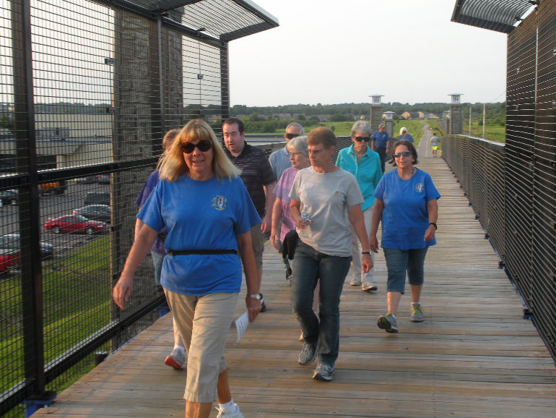

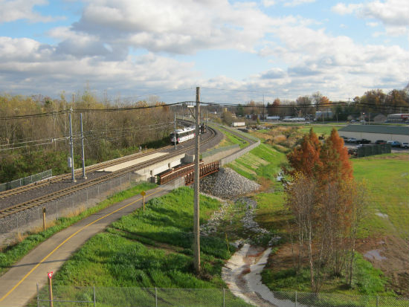

Dates: 1/2/2019 - 12/31/2019
City / State: Columbia, IL
Event Name: A Walk in Historic Columbia
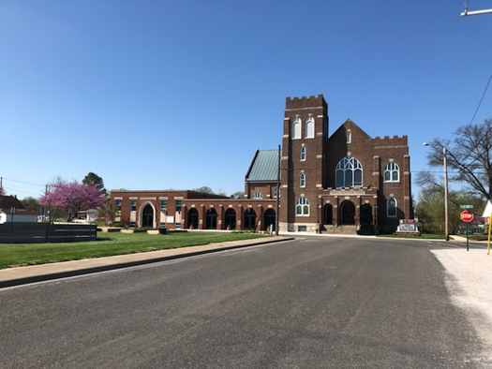
Event Type: Year Round Walk
Event ID: 111746 2019/Y2167 Distance - Trail Ratings: 5/6/11km - 1A
Description: The 5k will take you through St. Paul's Evangelical Cemetery, past the lake and through residential areas to Metter Park. Metter Park has a walking trail, gazebo, bandstand, and fountain. The 6k will take you down Columbia's Historic Main Street, with shops and restaurants, to Bolm Schuhkraft Memorial Park (locals call it "City Park") with a great walking trail and views from the bluff. Check payment is preferred.
Amenities: Strollers: Medium
Wheelchairs: medium Pets: Yes Restrooms: Yes
Special Programs: Make a Wish at a Water Fountain, Take a Walk In a City Park, Walk the USA - Street by Street
Start Times: Hours: M-F 6am - 4 pm, Sat 7am - 2pm, Sun 8am - 2pm.
Location: Cafe on the Abbey, 340 S Main Street, Columbia, Illinois. Driving Directions: From St. Louis: Take I-270/I-255 E to exit 6 for IL-3 S toward Columbia. Continue on IL-3; turn left on N. Main. From Belleville: Take IL-158 to S Main St in Columbia. Turn right onto S Main St. Cafe on the Abbey: (618)281-4554.
Awards & Fees: IVV Credit Only
Comments:
Host Club: Illinois Trekkers Volkssport Club
Contact: Jackie McKay (618) 616-1330
Website: www.illinois-trekkers.org
E-Mail Contact: jjmck1985@gmail.com

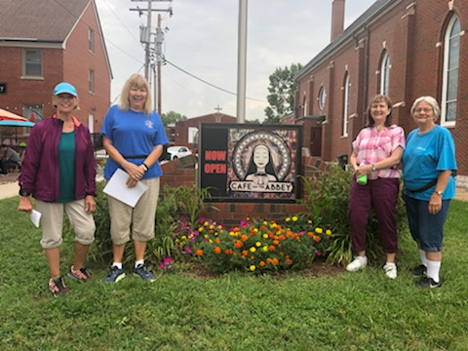

Dates: 1/1/2019 - 12/31/2019
City / State: Edwardsville, IL
Event Name: A Walk to Edwardsville Parks
Event Type: Year Round Walk

Event ID: 111744 2019/Y2168
Distance - Trail Ratings: 5/6/10km - 1A
Description: The 6k will take you to historic Leclaire Park and Lake. This community in Edwardsville was added to the National Register of Historic Places in 1979. The 5k will take you to Edwardsville Township Community Park. You will see two restored farm silos used for park storage and a US Navy A7E Corsair II aircraft.
Amenities: Strollers: Medium
Wheelchairs: medium Pets: Yes Restrooms: Yes
Special Programs: Take a Walk In a City Park, Walk the USA - Street by Street, Walking the USA A – Z
Start Times: Daily, dawn to dusk. YMCA hours Monday - Thursday: 5:00AM - 10:00PM
Friday: 5:00AM - 9:00PM
Saturday: 7:00AM - 8:00PM
Sunday: 10:00AM - 6:00PM
Location: Esic Center YMCA
Start Point / Driving Directions: 1200 ESIC DRIVE, EDWARDSVILLE, IL From I-270E take exit 9. Follow IL-157N to Esic Drive in Edwardsville.
Awards & Fees: IVV Credit Only
Comments:
Host Club: Illinois Trekkers Volkssport Club
Contact: Vickie Ridgeway (618) 792-3881 Website: www.illinois-trekkers.org
E-Mail Contact: ridgeway410@msn.com

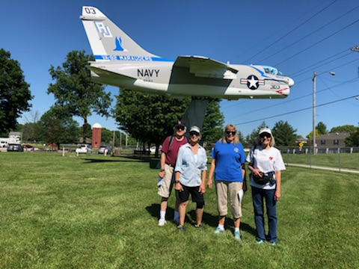

Dates: 1/1/2019 - 12/31/2019
City / State: Fairview Heights, IL
Event Name: St Clair Square Mall 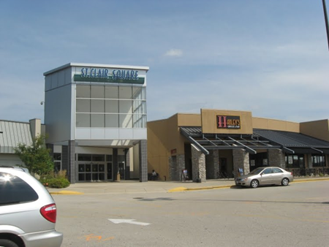

Event Type: Year Round Walk
Event ID: 111752 2019/Y0805
Distance - Trail Ratings: 5k, 10k - 1A

Description: Walkers are encouraged to walk when the weather is too hot, cold, rainy, etc. This walk is entirely inside the mall. Restrooms are available on each level and there is a full food court that opens at 10:00 am. Security is always available at the mall. Personal items left in the mall are the walker's responsibility. Do not leave valuables on chairs or benches unattended. Only service animals permitted inside the mall.
Amenities: Strollers: Easy
Wheelchairs: Easy Pets: No
Restrooms: Yes
Special Programs: Ice Cream Parlors
Start Times: 6:00 am to 9:00 pm
Location: Schnucks, 625 Lincoln Highway, Fairview Heights, IL. Ask for the Illinois Trekker box at the service counter. Please be courteous of store customers. Store hours are 6:00 a.m to 1:00 a.m.
Start Point / Driving Directions: Schnucks Market, 625 Lincoln Hwy, Fairview Heights,IL. From I64 take route 159 south. Turn left onto Lincoln Hwy (Scott Credit Union is on the left) and the Schnucks Market will be on the right. After registering for the walk drive two blocks to the Food Court entrance of the Mall on the north side of the parking lot on the upper level. Schnucks is open from 6:00 am to 1:00 am and the mall entrances are open for walkers 6:00 am to 9:00 pm
Awards & Fees: IVV Credit Only
Comments:
Host Club: Illinois Trekkers Volkssport Club
Contact: Trudy Duffman (618) 670-6920
Website: www.illinois-trekkers.org
E-Mail Contact: trudyduffman@yahoo.com

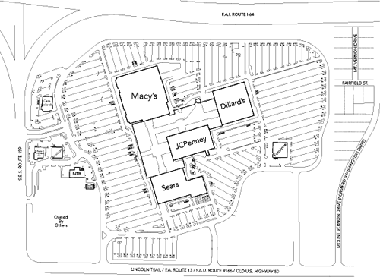

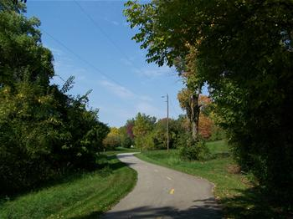

Dates: 1/1/2019 - 12/31/2019
City / State: Glen Carbon, IL
Event Name: A walk in "Old Town" Glen Carbon
Event Type: Year Round Walk
Event ID: 111579 2019/Y0808
Distance - Trail Ratings: 5k, 10k - 1A

Description: Trail is along historic streets, past local businesses and restaurants and on two scenic Rails-to-Trails. The route is two 5k loops from Centennial Library. Glen Carbon is listed on 100 Best Places to Live in USA and 50 safest cities in Illinois. Walk is open daily dawn to dusk. Restrooms and water are available at the start/finish. Pet are welcome but you must pick up after your pet.
Amenities: Strollers: Medium
Wheelchairs: Medium Pets: Yes
Restrooms: Yes
Special Programs: Bridges - Spanning the USA, Honoring Our Flag, National Register of Historic Places, Treasure Hunt - A way to walk our precious trails, Walk the USA - Street by Street, Points of Reference
Start Times:
Location: Casey's General Store
Start Point / Driving Directions: 70 S Main St, Glen Carbon, IL. From I64 take I255N to IL 162E (exit 29). Follow 162E to left on IL 157 to right on Main Street. Ask for the walk binder. Casey's General Store is open 5:00 am to 11:00 pm every day. After registering, drive 0.1 miles to Glen Carbon Centennial Library.
Awards & Fees: IVV Credit Only
Comments:
Host Club: Illinois Trekkers Volkssport Club
Contact: Susan Hodgson (618) 334-6304
Website: www.illinois-trekkers.org
E-Mail Contact: lkcs246@gmail.com

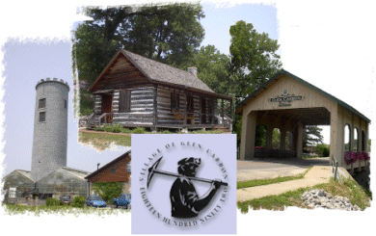

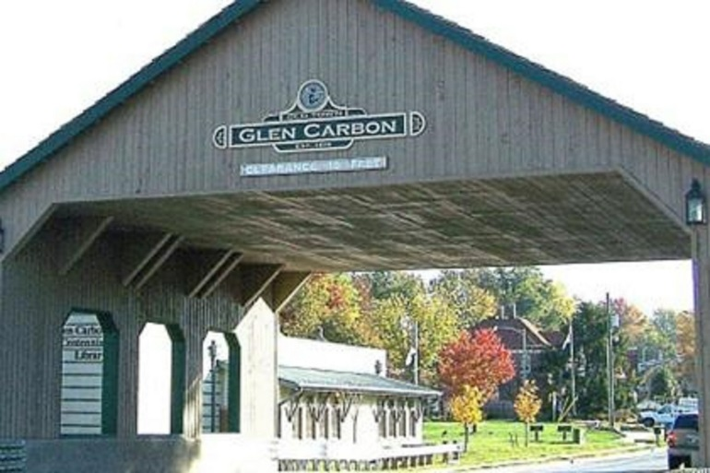

Dates: 1/2/2019 - 12/31/2019
City / State: Maryville, IL
Event Name:
Event Type: Year Round Walk
Event ID: 111747 2019/Y0903
Distance - Trail Ratings: 5K, 10K - 1A

Description: Center Hours: Mon- Fri: 5 am-9 pm; Sat: 7 am-5 pm; Sun: 12 noon-5 pm; closed on major holidays. Suggest you carry water. Please pay by check only. The trail has restrooms/water at the start/finish and at least one other point along the trail. The trail is a combination of the MCT Schoolhouse Bike trail and city streets of Maryville. This trail passes Maryville's favorite custard stand "Bobby's Frozen Custard" (web site: www.bobbysfrozencustard.com).
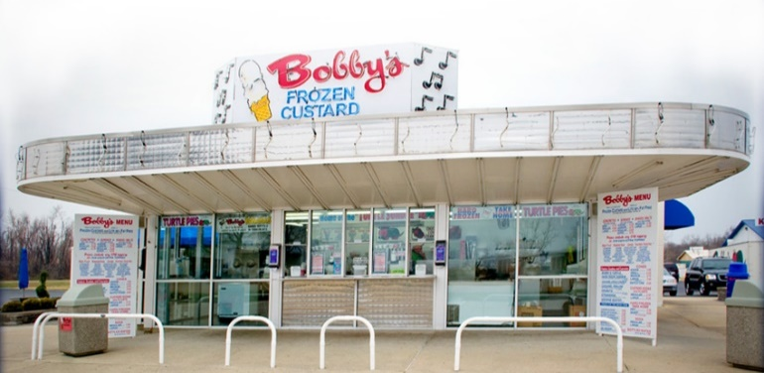
Madison County has some of the best bike trails you will find in the country with over 100 miles of asphalt bike trails. For more information on the bike trails please visit: www.mcttrails.org.
Amenities: Strollers: medium
Wheelchairs: medium Pets: Yes Restrooms: Yes
Special Programs: Ice Cream Parlors, Take a Walk In a City Park, Walking the USA A - Z
Start Times: See Extended Description.
Location: Collinsville-Maryville-Troy (CMT) YMCA
Start Point / Driving Directions: 618-346-5600. 1 Town Center Dr. Maryville, IL 62062. From the intersection of I-55/70 and IL Route 159, go North on IL 159 and turn LEFT (West) onto Town Center Dr. Follow the road to YMCA parking lot. Ask for the dark blue 'Walk Binder' at the reception desk.
Awards & Fees: IVV Credit Only
Comments:
Host Club: Illinois Trekkers Volkssport Club
Contact: Vickie Ridgeway (618) 792-3881
Website: www.illinois-trekkers.org
E-Mail Contact: ridgeway410@msn.com

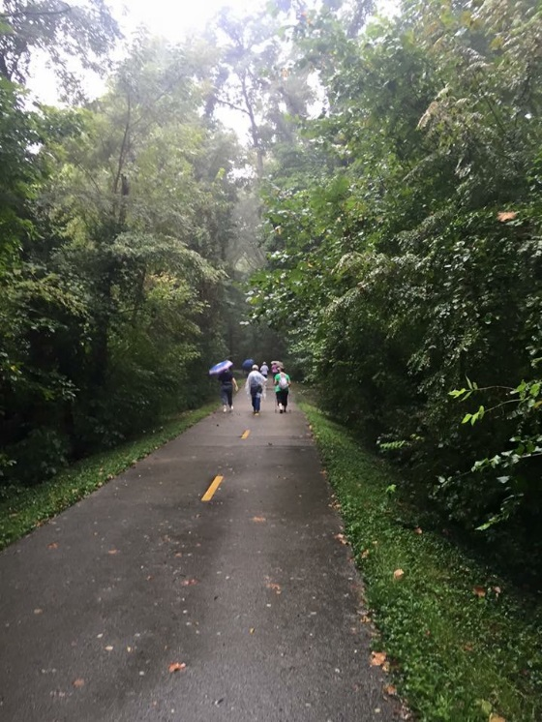

Dates: 1/1/2019 - 12/31/2019
City / State: O’Fallon, IL
Event Name: A Walk in the Parks
Event Type: Year Round Walk
Event ID: 111753 2019/Y2119
Distance - Trail Ratings: 5k, 10k - 1A
Description: We invite you to walk two of O'Fallon, Illinois' parks. Rocks Springs Park is located at the end of Third Street with a Dog Park and a Nature Center. O'Fallon Community Park is in the heart of O'Fallon near downtown shops and restaurants and houses the community swimming pool, sports fields, and other community facilities. We think you will enjoy the contrast between the two parks. Each park is a 5k walk to and from Schnucks.
Amenities: Strollers: Easy
Wheelchairs: Medium Pets: Yes Restrooms: Yes
Special Programs: Take a Walk In a City Park, Walking the USA A – Z
Location: Schnucks Market
Start Point / Driving Directions: Schnucks Market, 907 E. Highway 50, O'Fallon, Illinois. From I-64 take Exit 16 (North Greenmount Road O'Fallon/Shiloh). Exit toward O'Fallon on North Greenmount Road. Turn right on US Highway 50 (CVS on the corner). Continue on Highway 50 passing the O'Fallon Community Park on your left and turn left into the Schnucks parking lot. After entering Schnucks, go left to the Courtesy Desk at the front of the store and ask for the Walk binder. There are tables around the corner from the coffee bar.
Awards & Fees: IVV Credit Only
Comments:
Host Club: Illinois Trekkers Volkssport Club
Contact: Nikki Wilcoxen (618) 973-3825
Website: www.illinois-trekkers.org
E-Mail Contact: njwilcoxen@aol.com
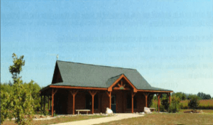

Swim Event
Dates: 1/1/2019 - 12/31/2019
City / State: Edwardsville, IL
Event Name: Edwardsville Swim
Event Type: Year Round Swim
Event ID: 111745 2019/Y2183
Distance: 300m - 1A
Description: Swim or walk 300m in the Indoor pool. There is a link to the "pool schedule" at www.edwardsvilleymca.com. Look for the "Esic Center Indoor Pool Schedule" or call at (618)656-0436.Center Hours: M-Th 5a-10p, Fri 5a-9p, Sat 7a-8p, Sun 10a-6p. Center is closed New Year's Day, Easter, Memorial Day, July 4th, Thanksgiving and Christmas. Center closes early on New Year's Eve and Christmas Eve.
Amenities: Strollers: Easy Wheelchairs: Easy
Pets: No Restrooms: Yes
Special Programs: None
Location: Esic Center YMCA
Start Point / Driving Directions: 1200 ESIC DRIVE, EDWARDSVILLE, IL From I-270E take exit 9. Follow IL-157N to Esic Drive in Edwardsville.
Awards & Fees: IVV Credit Only
Comments:
Host Club: Illinois Trekkers Volkssport Club
Contact: Vickie Ridgeway (618) 792-3881 Website: www.illinois-trekkers.org
E-Mail Contact: ridgeway410@msn.com

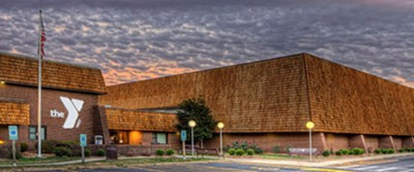

BIKE 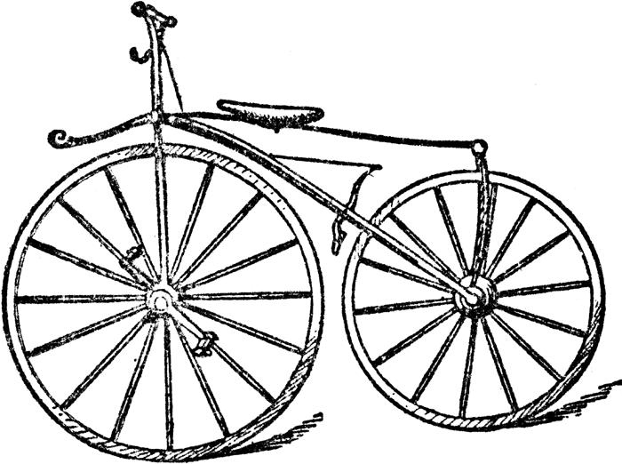
EVENTS
Dates: 1/2/2019 - 12/31/2019
City / State: Belleville, IL
Event Name: YMCA - Bike
Event Type: Year Round Bike
Event ID: 111750 2019/Y1517
Distance - Trail Ratings: 25km - 1A

Description: Center Hours: Mon-Thurs: 5 a.m.-10 p.m.; Fri: 5 a.m.-9 p.m. (3rd Friday of the month the center will host Parents Night Out); Sat: 6 a.m.-6 p.m.; Sun: 12noon-6 p.m. Closed on major holidays. Trail generally level, incorporating country roads, paved streets through neighborhoods, Southwestern Illinois College and the Richland Creek Greenway. Water and Restrooms are available at the start/finish and along the trail at the Belleville Metrolink station. Suggest you carry water. Check payment is preferred.
Amenities: Strollers: NO Wheelchairs: NO Pets: No Restrooms: Yes
Special Programs: This event doesn't have any special Programs assigned.
Start Times:
Location: YMCA - East Belleville
Start Point / Driving Directions: 618-236-9983. 2627 Carlyle Ave. From I-64 take exit 16 onto Greenmount Rd in the direction of Shiloh. Proceed South for approximately four miles. Turn left at the light onto Carlyle Ave. (IL-161). The YMCA will be on your left at the third light. Reception desk will have the Blue "Volksmarch Binder". The start is also accessible by Metrolink at College station.
Awards & Fees: IVV Credit Only
Comments:
Host Club: Illinois Trekkers Volkssport Club
Contact: Charles/Susan Botula (618) 236-9521
Website: www.illinois-trekkers.org
E-Mail Contact: packysuba@juno.com

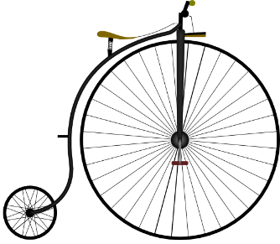

Dates: 1/2/2019 - 12/31/2019
City / State: Maryville, IL
Event Name: Bike
Event Type: Year Round Bike
Event ID: 111748 2019/Y1898
Distance - Trail Ratings: 27, 36, 50, 58 or 70km - 1A

Description: Center Hours: Mon-Fri: 5 am-9 pm; Sat: 7 am-5 pm; Sun: 12 noon-5 pm; closed on major holidays. Suggest you carry water. Please pay by check only. Restrooms/water are available at the start/finish. 1 or 2 restrooms are available on the trail depending on the length of trail selected. All of the trails are entirely on the Madison County Transit (MCT) Bikeway trails. Madison County has some of the best bike trails you will find in the country with over 100 miles of bike trails. For more information on the bike trails please visit: www.mcttrails.org.
Amenities: Strollers: NO Wheelchairs: NO Pets: No Restrooms: Yes
Special Programs: This event doesn't have any special Programs assigned.
Start Times: See Extended Description.
Location: Collinsville-Maryville-Troy (CMT) YMCA
Start Point / Driving Directions: 618-346-5600. 1 Town Center Dr. Maryville, IL 62062. From the intersection of I-55/70 and IL Route 159, go North on IL 159 and turn LEFT (West) onto Town Center Dr. Follow the road to YMCA parking lot. Ask for the dark blue 'Walk Binder' at the reception desk.
Awards & Fees: IVV Credit Only
Comments:
Host Club: Illinois Trekkers Volkssport Club
Contact: Vickie Ridgeway (618) 792-3881
Website: www.illinois-trekkers.org
E-Mail Contact: ridgeway410@msn.com

