First 10 event challenge

must have 6 Illinois Trekker sanctioned events.

1. ___Trekker AVA Event____

2. ___Trekker AVA Event____

3. ___Trekker AVA Event____

4. ___Trekker AVA Event____

5. ___Trekker AVA Event____

6. ___Trekker AVA Event____

7. _Greater STL AVA Event__

8. _Greater STL AVA Event__

9. _Greater STL AVA Event__

10. _Greater STL AVA Event__

**Congrats You Finished**

**the First Level**

In second 10 events

must have 6 Illinois Trekker YREs + Work at 1 event

11. ___Trekker YRE Event____

12. ___Trekker YRE Event____

13. ___Trekker YRE Event____

14. ___Trekker YRE Event____

15. ___Trekker YRE Event____

16. ___Trekker YRE Event____

17. _Work Trekker AVA Event_

18. _Greater STL AVA Event__

19. _Greater STL AVA Event__

20. _Greater STL AVA Event__

**Congrats You Finished**

**the Second Level**

In third 10 event challenge

must do all 9 Illinois Trekker YREs

21. ___Belleville Downtown___

22. ___Belleville East YMCA__

23. ___Belleville Shrine_______

24. ­­_______Columbia_________

25. ___Edwardsville YMCA___

26. ___Fairview Heights Mall__

27. _____Glen Carbon________

28. __Maryville CMT YMCA__

29. ___O’Fallon (Schnucks)____

30. _Greater STL AVA Event__

**Congrats You Are**

**Almost There!!!!!!**

In last 10 event challenge

must have 3 Illinois Trekker events + Work at 1 event.

31. ___Trekker AVA Event____

32. ___Trekker AVA Event____

33. ___Trekker AVA Event____

34. _Work Trekker AVA Event_

35. _Greater STL AVA Event__

36. _Greater STL AVA Event__

37. _Greater STL AVA Event__

38. _Greater STL AVA Event__

39. _Greater STL AVA Event__

40. _Greater STL AVA Event__

**Congrats You Have**

**Finished Third Level!**

**Illinois Trekkers 40th Anniversary Challenge**

Volksmarching started because a few German runners thought that everyone should be a winner, not just the first three people over the finish line. With that in mind the challenge has been designed to reward as many club members as possible.

For our 40th Anniversary, the Challenge record book has three completion levels available to club members only. Members are eligible for an award at each level of completion.

Qualifications are:

AVA sanctioned events only (YR or Traditional)

Event includes: to work, walk, bike, or swim

Work & Walk same event = 2 stamps in book

You must carry and complete a start card for each event. Appropriate registration fee must be paid for each event.

**Level 1:** 10 Events = *First Award*

**Level 2:** 10 more Events-includes work at 1 Traditional Events = *Second Award*

**Level 3:** 20 more Events-includes work at 1 more Traditional Event = *Third Award*

This Challenge begins January 1 and ends December 31, 2020.

Do it again for other awards!

If any concerns/questions arise the 40th Challenge committee will make the final ruling.

For detailed information on each walk:

[www.**illinois**-**trekkers**.org](http://www.illinois-trekkers.org)

**This book belongs to:**

_________________________________

**2020 Walking Challenge**

**40 Walks in 52 Weeks**

**ILLINOIS TREKKERS**

**40TH ANNIVERSARY**



AVA CLUB #047

Illinois State #1

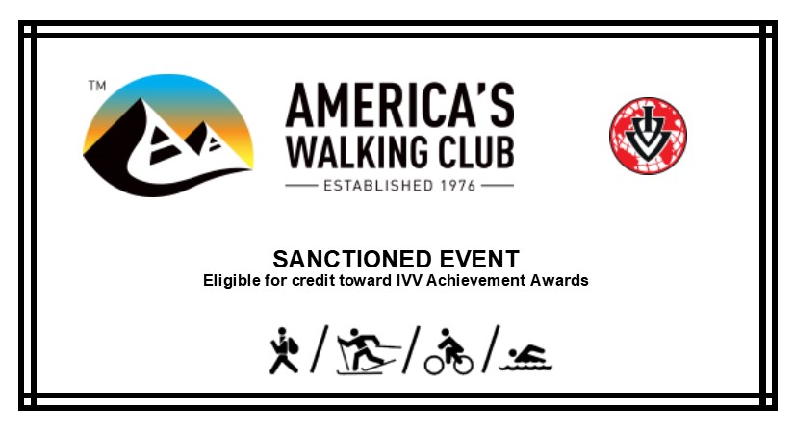

@ 2020 Illinois Trekkers